National Textile University, Faisalabad


Department of Computer Science

Name: | Amna Khalid
Class: | BSCS_A 5th Semester
Registration No: | 23-NTU-CS-1016
Assignment : | 2
Course Name: | Embedded & IOT systems
Submitted To: | Sir Nasir Mahmood
Submission Date: | 20/12/2025

Homework-01 – After mid

Embedded IOT Systems

Question-1 ESP32 Webserver (webserver.cpp):

Part A: Short Questions:

1. What is the purpose of Webserver server(80); and what does port 80 represent?

Answer:

- This line creates a web server on the ESP32. It allows the ESP32 to show a webpage to users.
- Port 80 is the normal port used for websites on the internet. When we open the ESP32 IP address in a browser, the request automatically goes to port 80. That is why we do not need to write the port number in the URL.

2. Explain the role of server. On("/", handle Root); in this program.

Answer:

This line tells the ESP32 what to do when someone opens the home page of the website.
The symbol / means the main page. When the browser asks for this page, the ESP32 runs the handle Root() function and sends the webpage to the user.

3. Why is server.handleClient(); placed inside the loop() function? What will happen if it is removed?

Answer:

server.handleClient(); checks if a user is trying to connect to the web server.
It is placed inside the loop() so the ESP32 can keep checking repeatedly.
If this line is removed, the web server will not respond to any browser request, and the webpage will not open.

4. In handleRoot(), explain the statement:

server.send(200, "text/html", html);

Answer:

This statement sends a response from the ESP32 to the client’s web browser. The number 200 indicates that the request was successful. The "text/html" part tells the browser that the content being sent is an HTML webpage. The variable html contains the actual webpage code. Together, this line delivers a properly formatted webpage to the user.

5. Difference between displaying last measured sensor values and taking a fresh DHT reading inside handleRoot()?

ANSWER:

- Showing the last measured values means the ESP32 displays sensor data that was already read before. This is fast and safe for the sensor.

- Taking a fresh DHT reading inside handleRoot() means the sensor is read every time the page is refreshed. This can slow down the system and may cause sensor errors.
So, using previously stored values is usually better.

Part B: Long Question:

Statement :
Describe the complete working of the ESP32 webserver-based temperature and humidity monitoring system.

Answer:

Working of ESP32 Webserver-Based Temperature and Humidity Monitoring System

The ESP32 webserver-based temperature and humidity monitoring system allows users to view environmental data through a web browser. The system uses Wi-Fi connectivity, a DHT sensor, an OLED display, and a web interface. The complete working is explained below in simple points:

1. ESP32 Wi-Fi Connection Process and IP Address Assignment

- When the ESP32 is powered on, it starts by connecting to a nearby Wi-Fi network using the stored SSID and password.
- The ESP32 keeps checking the connection status until it successfully connects to the router.
- Once connected, the router assigns a unique IP address to the ESP32.
- This IP address is used by users to access the ESP32 web server through a web browser.
- The IP address is usually displayed on the Serial Monitor for user reference.

2. Web Server Initialization and Request Handling

- After connecting to Wi-Fi, the ESP32 initializes a web server, usually on port 80.
- The web server is programmed to respond to specific URL requests such as the home page.
- When a user enters the ESP32 IP address in a browser, a request is sent to the server.
- The server processes this request using defined handler functions.
- The handleClient() function continuously listens for incoming requests and sends responses.

3. Button-Based Sensor Reading and OLED Update Mechanism

- A physical button is used to control when the sensor data is read.
- When the button is pressed, the ESP32 reads temperature and humidity values from the DHT sensor.
- These values are stored in variables for later use.
- At the same time, the OLED display is updated to show the latest temperature and humidity readings.
- This method prevents unnecessary sensor readings and improves system stability.

4. Dynamic HTML Webpage Generation

- The ESP32 creates an HTML webpage using strings inside the program.
- Sensor values are inserted into the HTML code dynamically before sending it to the browser.
- Each time the page is loaded or refreshed, the updated sensor values are displayed.
- This allows users to monitor temperature and humidity in real time from any device on the same network.

5. Purpose of Meta Refresh in the Webpage

- The meta refresh tag is used to automatically reload the webpage after a fixed time interval.
- This helps in updating sensor values without manually refreshing the browser.
- It provides a live monitoring experience for the user.
- The refresh interval is kept reasonable to avoid overloading the ESP32 or sensor.

6. Common Issues in ESP32 Webserver Projects and Their Solutions

- Wi-Fi connection failure: Caused by wrong credentials or weak signal. Solution is to verify Wi-Fi details and improve signal strength.

- Webpage not loading: Often due to missing handleClient() in the loop. Adding it ensures proper request handling.

- DHT sensor errors: Caused by frequent readings. Using delays and button-based reading helps fix this.

- Slow server response: Happens when too many tasks run together. Using efficient code and non-blocking methods improves performance.

- OLED not updating: Usually due to incorrect I2C address or missing display refresh command. Correct wiring and code solve this issue.

Question-2 Blynk Cloud Interfacing (blynk.cpp)

Part-A: Short Questions

1. What is the role of Blynk Template ID in an ESP32 IoT project? Why must it match the cloud template?

Answer:

- The Blynk Template ID connects the ESP32 device to a specific template on the Blynk cloud.
- The template defines widgets, virtual pins, and device layout.
- If the Template ID does not match, the cloud cannot link the device correctly.
- Matching ensures proper data exchange between the ESP32 and the Blynk app.

2. Differentiate between Blynk Template ID and Blynk Auth Token.

Answer:

- Blynk Template ID identifies the device template shared by many devices.
- Blynk Auth Token is a unique key for one specific device.
- Template ID defines structure, while Auth Token provides device authentication.
- Both are required for successful cloud connection.

3. Why does using DHT22 code with a DHT11 sensor produce incorrect readings? Mention one key difference between the two sensors.

Answer:

- DHT11 and DHT22 use different data formats and timing.
- DHT22 code cannot correctly read DHT11 signals.
- A key difference is accuracy: DHT22 is more precise than DHT11.
- Using correct sensor code ensures proper readings.

4. What are Virtual Pins in Blynk? Why are they preferred over physical GPIO pins for cloud communication?

Answer:

- Virtual Pins are software-based pins used for data transfer in Blynk.
- They are not tied to real ESP32 hardware pins.
- Virtual Pins allow flexible app design without changing wiring.
- They are safer and easier for cloud-based communication.

5. What is the purpose of using BlynkTimer instead of delay() in ESP32 IoT applications?

Answer:

- BlynkTimer runs tasks without stopping the program.
- delay() blocks execution and affects Wi-Fi and cloud connection.
- BlynkTimer always keeps the ESP32 responsive.
- It improves performance and stability in IoT projects.

Part-B: Long Question:

Statement:
Explain the complete workflow of interfacing ESP32 with Blynk Cloud to display temperature and humidity values.

Answer:

Creation of Blynk Template and DataStream:

- First, a device template is created on the Blynk Cloud platform.
- The template acts as a blueprint that defines how the device will work.
- Datastreams are added inside the template to store temperature and humidity values.
- Each datastream is linked to a virtual pin (such as V0 for temperature and V1 for humidity).
- Widgets like labels or gauges are then connected to these virtual pins in the Blynk app.

2. Role of Template ID, Template Name, and Auth Token

- Template ID connects the ESP32 code to the correct cloud template.
- Template Name is a readable name used for identification and clarity.
- Auth Token is a unique security key assigned to each device.
- The ESP32 uses these details to authenticate itself and send data to the Blynk Cloud.
- If any of these values are incorrect, the device will fail to connect.

3. Sensor Configuration Issues (DHT11 vs DHT22)
- DHT11 and DHT22 sensors look similar but work differently.
- DHT11 has lower accuracy and a smaller temperature range.
- DHT22 is more accurate and provides higher resolution readings.
- Using DHT22 code for a DHT11 sensor causes incorrect or unstable readings.
- Selecting the correct sensor type in the code ensures proper data measurement.

4. Sending Data Using Blynk.virtualWrite()

- After reading temperature and humidity from the sensor, the values are stored in variables.
- The Blynk.virtualWrite() function is used to send these values to the cloud.
- Each value is sent to its corresponding virtual pin.
- The Blynk Cloud updates the app widgets in real time.
- This allows users to monitor sensor data from anywhere.

5. Common Problems During Configuration and Their Solutions

- Device not connecting to Blynk: Caused by incorrect Template ID or Auth Token. Solution is to verify credentials.
- No sensor values shown: Usually due to wrong virtual pin mapping or incorrect sensor type in code.
- Frequent disconnections: Occur when delay() is used excessively. Using BlynkTimer fixes this issue.
- Incorrect readings: Result from mismatched sensor code. Using correct DHT library and sensor definition solves the problem.

Screenshots :

Templelate :
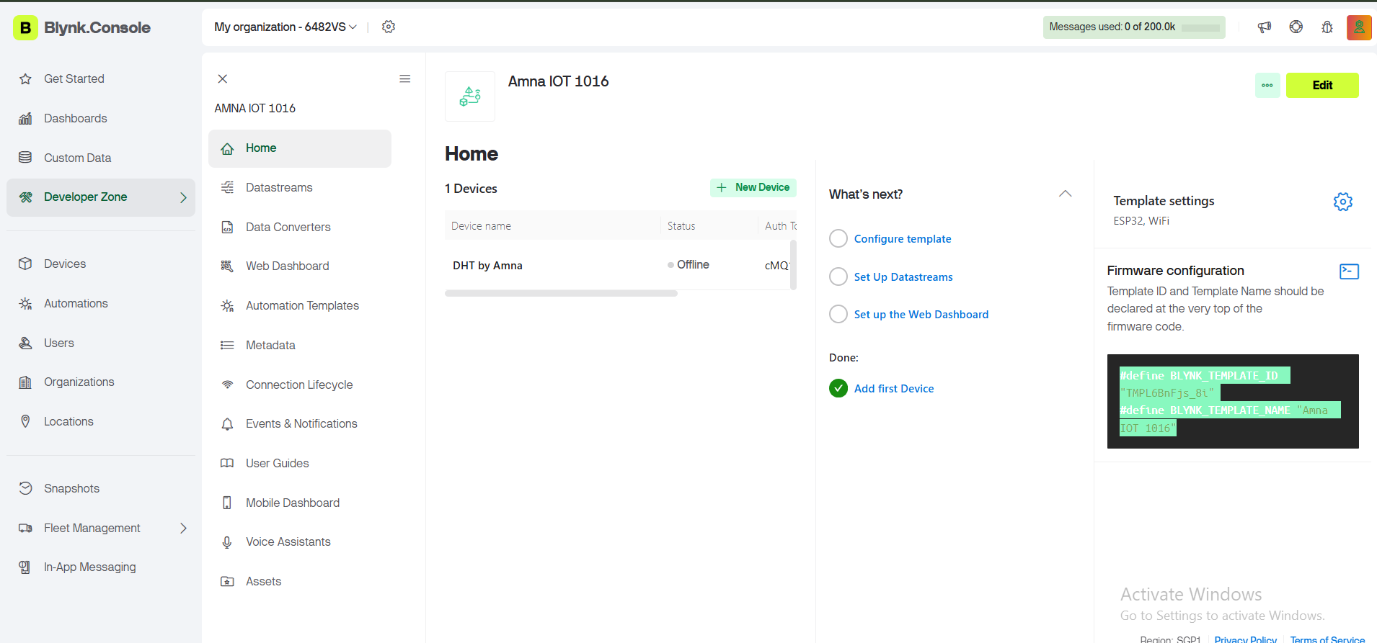

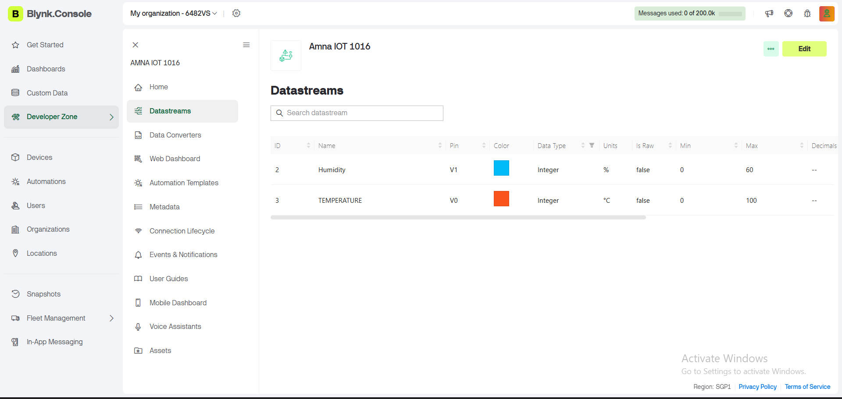

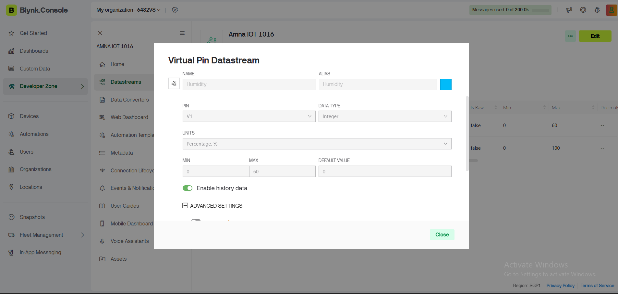

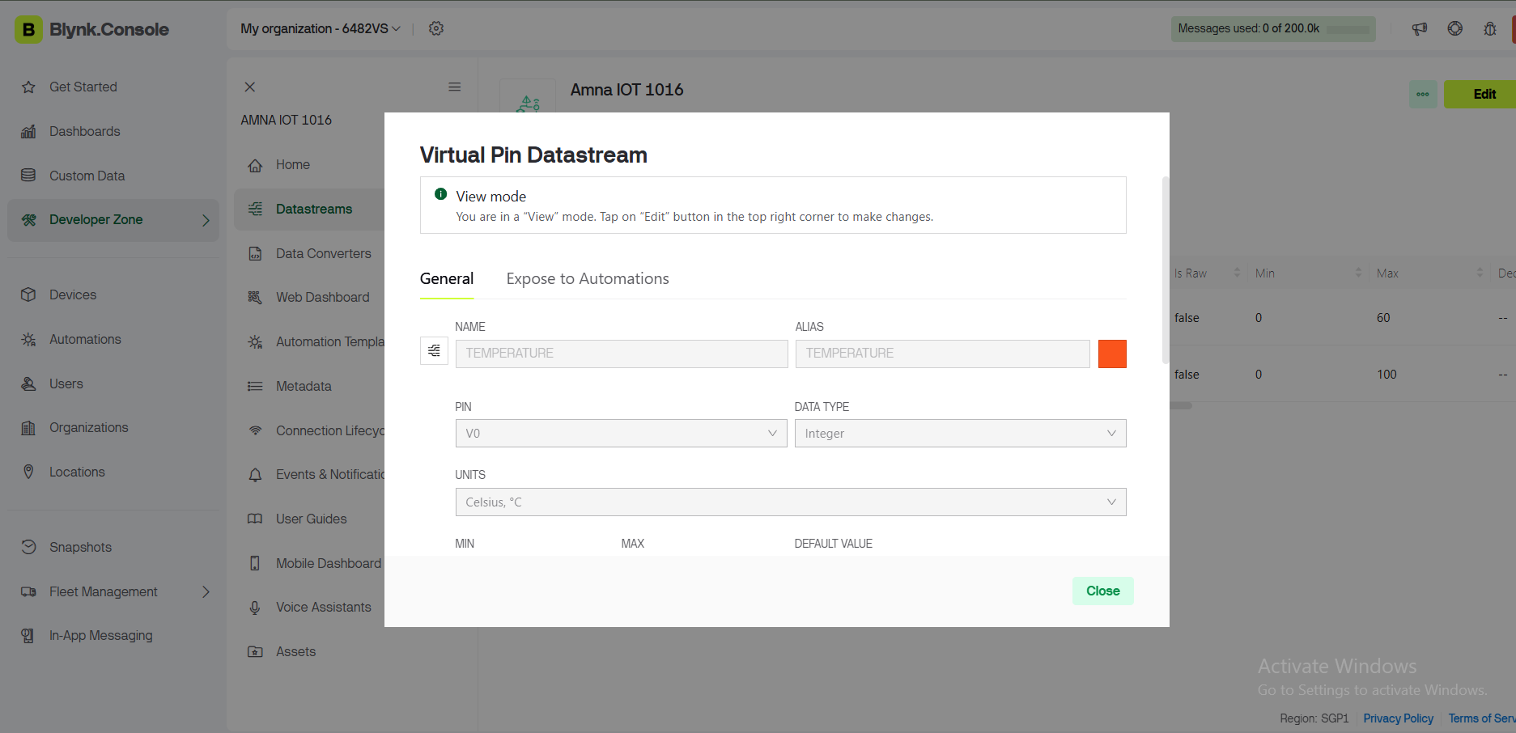

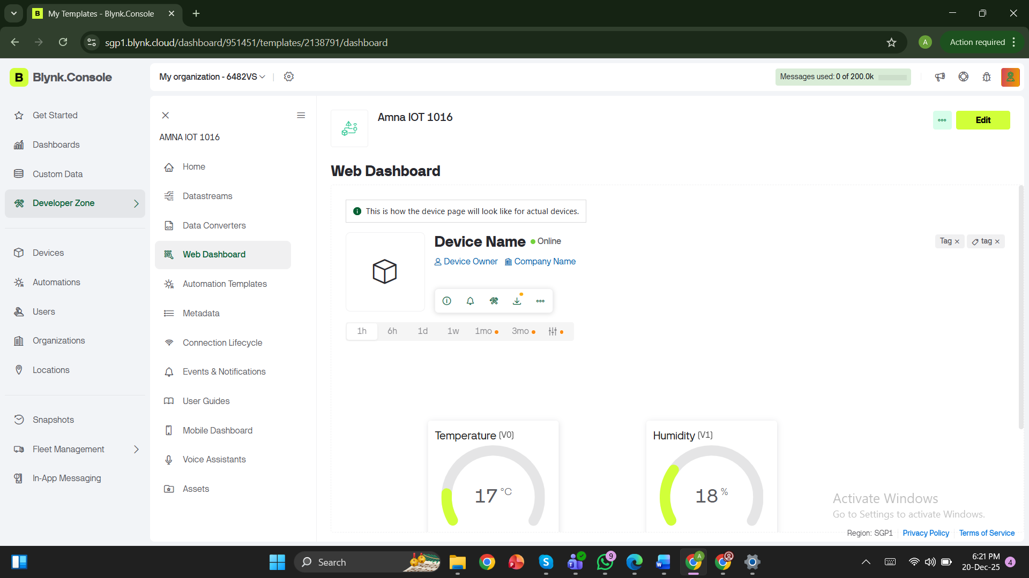

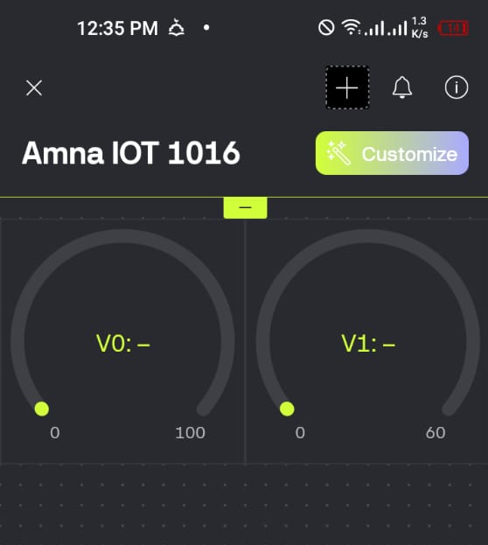

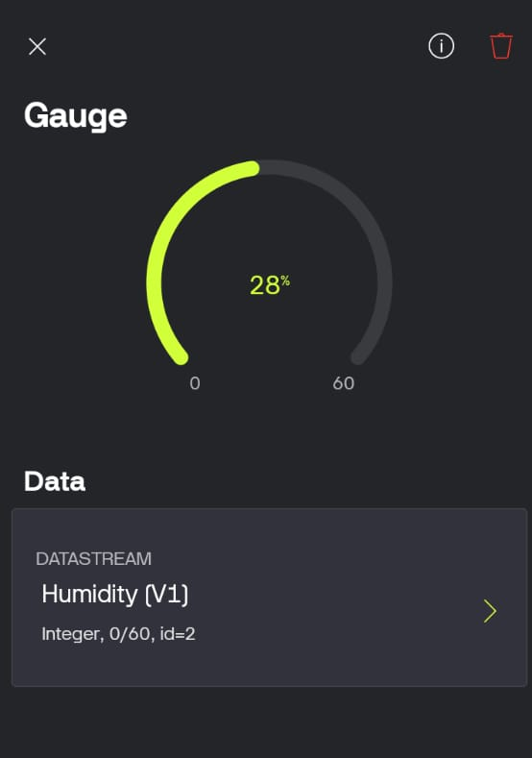
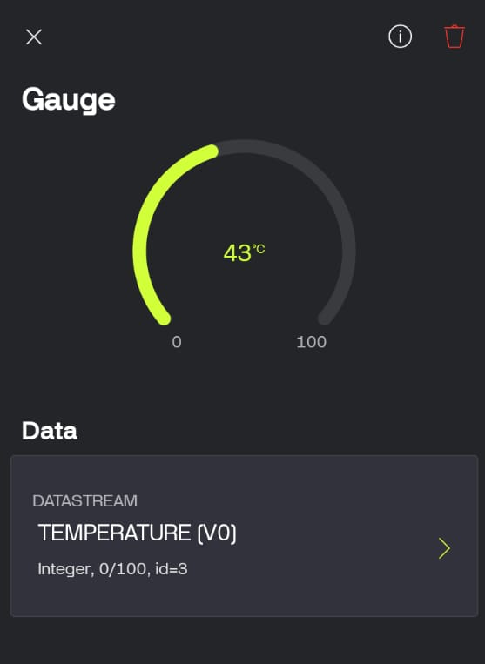
Git hub link :
https://github.com/Amnaworkspace/embedded_iOT_1016_Amna.git

